Developing Research Papers from Machine Learning experiments- A practical Guide I (Title of the paper here pls.)
Name of 1st Member¹, Name of 2nd Member², Name of 3rd Member³ …. Name of n^{th} Member^{n}
Department of Computer Science, College of Computer Science and Information Technology, Imam Abdulrahman Bin Faisal University, P.O. Box 1982, Dammam 31441, Saudi Arabia
¹email for 1st member, ²email for 2st member, ……..^{n}email for n^{th} member
Abstract
Here you will need to provide summarized introduction to the paper, including discussions answering the questions what? why? (why is the topic necessary to be investigated? , any work done earlier? What is the gap and the justification for going ahead with this new efforts?) and how (+ why of the how options, like why SVM is chosen)? And then brief summary of the result outcome and implication of the results….
Additionally, under the “why” remember to also include brief summary of what were done earlier and the identified gap that still necessitated your proposed idea.
There should be no citation in abstract please!
Keywords: insert important words related to your project here. Usually 5 words should be fine but it could be more or less by 1.
1. Introduction
Here you will need to provide general introduction to the paper making the report very interesting to read. It must however include discussions answering the questions what? why? (why is the topic necessary to be investigated? , any work done earlier? You also need to briefly mention if any efforts have been made earlier and why there is still need for this your work. ? What is the gap and the justification for going ahead with this new efforts?) and how ? how you wish to solve the problem? i.e. method to be used? (+ why of the how options, like why SVM is chosen)? Note that you must support everything discussed with enough citation to show your grasp of the selected topic. Also provide summary of result outcome briefly.
This should end with a paragraph stating that:
The remaining part of this work is organized as follow. Section 2 contains review of related literatures. Section 3 contains the proposed machine learning techniques (i.e. X and Y or X, Y, and Z classifiers). Section 4 contains empirical studies that include dataset description, experimental setup or methodology, and the adopted optimization strategy or parameter search strategy (if any). Section 5 presents results and discussion while section 6 contains the conclusion and recommendation emanating from this work.
There should be as much citation as possible in the introduction to show your grasp of the field and the earlier research. Sometimes literature review could be combined with introduction in a summary form most especially in conference papers or journals with limited number of papers. But in this case we have a separate section for literature review.
2. Review of Related Literatures
Here you provide literature review of earlier works done in the area of the chosen topic. Special focus should be on using published papers in journals and conferences. Make sure you end you literature review with at least one paragraph stating the gap detected in the literature and linking it or using it to justify your proposed work in this paper.
Summarize your literature review in a tabular form for easier grasping and appealing look.
Finally, make sure you end your literature review with at least one paragraph stating the gap detected in the literature and linking it or using it to justify your proposed work in this paper. Also it will be great to have a small table contains check signs identifying the present gaps.

More importantly, the lit review should place more emphasis on the previous works that used the same dataset as the one you are using in this paper. And let it be clear what they have obtained till date and then link that with the gap identified and then under discussion you will have to compare your new results with the particular paper(s) that used the same data as yours, especially the most recent papers of them. However if there is no one has ever used the dataset, then it is okay.
4.0 Description of the Proposed Techniques (at least two ML techniques must be chosen)
Here you present the description of each of the proposed techniques one after the other (avoid unnecessary details, …and end it by referring readers to sources with with more details…).
4.1 Technique #1

4.2 Technique #2

4.3 Technique #3
...
..
5.0 Empirical Studies
5.1 Description of dataset
Provide detailed description of dataset here. You may put the dataset in table at the appendix, if the size is reasonable enough for that.
5.1.1 Statistical Analysis of the Dataset
The statistical analysis of the dataset is presented in table x below. The mean, median, standard deviation, maximum and minimum values of the dataset are presented.
Table x: Statistical Analysis of the dataset
 | Mean | Median | Standard deviation | Maximum | Minimum
E_{S} (Jm⁻²) | 1.804 | 2.375 | 1.297 | 3.68 | 0.095
∆E(eV) | 4.152 | 4.195 | 2.837 | 8.66 | 0.804
a (Å) | 3.813 | 3.396 | 1.049 | 6.045 | 2.860
c(Å) | 3.813 | 3.396 | 1.049 | 6.045 | 2.860
B(10¹¹Jm⁻³) | 1.312 | 1.625 | 1.078 | 3.23 | 0.020
E^{f}(eV) | 1.623 | 1.600 | 1.197 | 4.00 | 0.280

Table xx: Correlation between each Attribute and the Target attribute
Attributes' pairs | Correlation coefficient
∆E(eV) and E_{S} (Jm⁻²) | 0.96
a (Å) and E_{S} (Jm⁻²) | -0.81809
c(Å)and E_{S} (Jm⁻²) | -0.81809
B(10¹¹Jm⁻³) and E_{S} (Jm⁻²) | 0.973
E^{f}(eV) and E_{S} (Jm⁻²) | 0.963

5.2. Experimental Setup
Here you describe how you carry out the experiment. E.g. you may mention the experiment was carried out using weka…….. Also you mention how you partition your data. (E.g. we used both direct partitioning and also 10-fold cross validation or one of them- it is very important to use the same partition method as the previous research that you wish to compare your work with). State other descriptions that will make it possible for other people to repeat your experiment (This is a necessity for good research outcome.). Describe how you set up the experiment and how you use your methods and the parameters used. Make this section very clear so that it will be easy for anyone to just read this section and easily repeat your experiments. Having something to make the experimental procedure very clear is very nice, especially in the form of flowchart, flow diagram, framework representing the proposed models, etc.

Or better modified to suit your own area of application/utilization.
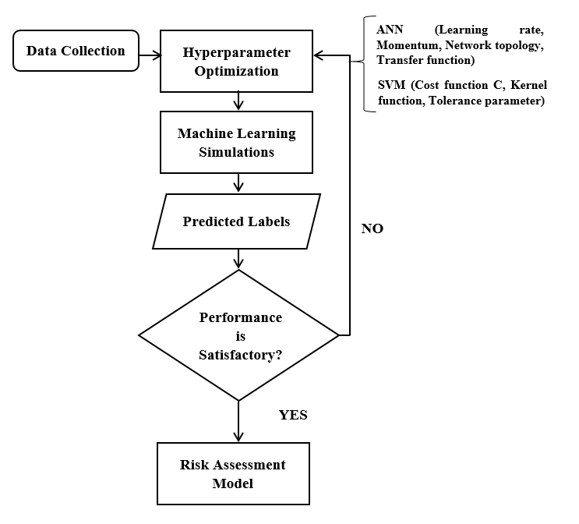
5.3 Performance Measures
Here you give brief description or mention of the choice of performance and if possible state the reason for such. (e.g. based on the literature in the same field, etc)

Figure 2. SVM hyper-parameter search for the kernel function

Figure 3. SVM hyper-parameter search for the cost function

Figure 4. SVM hyper-parameter search for the tolerance parameter, epsilon

